Vidar Foundation

1906 South Orr Lake Rd.
Elmvale, ON
L0L 1P0

Vidar Foundation Tuition Loan Program

In partnership with

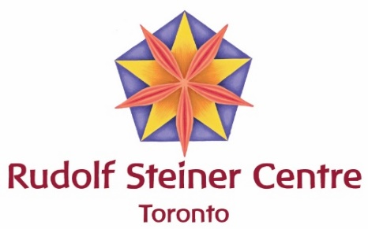

Rudolf Steiner Centre * 9100 Bathurst St. #4 * Thornhill, ON L4J 8C7

905 764 7570 * info@rsct.ca * www.rsct.ca

1014 LaBelle Road
Castlegar BC, V1N 4R3
Canada
Email: info@westcoastinstitute.org
Telephone: 604-740-0539

Vidar Foundation Tuition Loan
2020/21 Program
Introduction
There is a demonstrated need for more Waldorf teachers and Waldorf early childhood educators across Canada. However, some prospective students are unable to afford the tuition for the relevant training courses available through the Rudolf Steiner Centre Toronto (RSCT) and the West Coast Institute for Studies in Anthroposophy (WCI). While these organizations have access to some bursary funding through the Association of Waldorf Schools of North America and some other tuition support, it is not sufficient to enable all eligible student to enroll.
The Rudolf Steiner Centre Toronto (RSCT) and the West Coast Institute for Studies in Anthroposophy (WCI) have partnered with the Vidar Foundation who established the Vidar Tuition Loan Program for Waldorf Teacher Education and Waldorf Early Childhood Education Students in Canada (VTLP).
VTLP Terms
VTLP will offer limited, no-interest loans to students to cover tuition and other expenses associated with becoming a Waldorf teacher or Waldorf early childhood teacher through RSCT and WCI. Loans will be secured through community co-signers (‘loan guarantors’) and will be repayable over a five-year period following graduation.
A loan may granted for a 1 year, 2 year or 3 year course of study. While loans may be repaid sooner, all loans must be repaid within five years following graduation. Monthly loan repayment rates must be at a minimum repayment rate of $100/month or higher. In addition to repayment, all students will be charged a 5% “Growth Contribution” payable upon enrolment.
Vidar is offering a bursary of up to 50% of their total loan amount for students who complete their training. Vidar will forgive 25% of the student's loan as a bursary after the teacher has worked for a first school year at a Canadian Waldorf School, and a second 25% after a second completed year of teaching.
Once contracted, students’ loans will be directly transferred from the VTLP account to RSCT and WCI accounts, according to the regular payment schedule that students would normally follow if paying on their own.
Loan guarantors
Each loan applicant will be asked to try to identify and approach community members who would be willing to act as loan co-signers (loan guarantors) and support their loan application in this way. The training institution will work with the applicant as required to secure sufficient loan guarantors, including locating guarantors from amongst the broader anthroposophical community as required.
A co-signer agrees to pay back a portion of the loan should the student in question default on the payments. Co-signers sign a simple contract confirming their willingness to underwrite a specific portion of the loan.
VTLP Loan application process
The loan application process consists of 3 stages:
- Students submit the Vidar loan application form to RSCT or WCI (see below);
- A short interview is held between the student and the RSCT/WCI representative;
- RSCT/WCI communicates the final decision to the student.

